**FORCE (HYDROSTATIC FORCE PROBLEMS)**

General

* Always slice horizontally so the pressure is nearly constant throughout the slice
* Start with the origin of the axis system at the bottom of the submerged shape
* Build up the force formula from density paying close attention to units (see table below)

|  |  |
| --- | --- |
| **Metric Units** | **US Units** |
| $$Mass Density of Water \left(1000 \frac{kg}{m^{3}}\right)$$ | $$Weight Density of Water \left(62.5 \frac{lb}{{ft}^{3}}\right)$$ |
| $$Weight Density of Water\left(\frac{N}{m^{3}}\right)$$ $$=Density\left(\frac{kg}{m^{3}}\right)*Acceleration\left(\frac{m}{s^{2}}\right)$$ | $$Pressure\left(\frac{lb}{{ft}^{2}}\right)$$ $$=Density\left(\frac{lb}{{ft}^{3}}\right)*Depth\left(ft\right)$$ |
| $$Pressure\left(Pa\right)$$ $$=Weight Density of Water\left(\frac{N}{m^{3}}\right)*Depth\left(m\right)$$ | $$Force\left(lb\right)$$ $$=Pressure\left(\frac{lb}{{ft}^{2}}\right)*Area\left({ft}^{2}\right)$$ |
| $$Force\left(N\right)=Pressure\left(\frac{N}{m^{2}}\right)*Area\left(m^{2}\right)$$ |  |

Example 1. The vertical plate shown below is submerged in water. Set up the integral to find the hydrostatic force against one side of the plate.

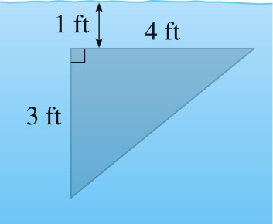

Example 2. The vertical plate shown is submerged in water. Set up the integral to find the hydrostatic force against one side of the plate.

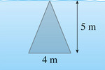

Example 3. A vertical dam has a semicircular gate as shown below. Find the hydrostatic force against the gate.

